The intrinsic value of a call spread is the difference between the strikes.

I can see this is Black Scholes.

Then this is for modelling storage

Model tankers (routes), power plants, storage, refineries, pipelines, parlines

**Power Plants/Energy**

Heat rate (efficiency or power plant) of a power plant (say it’s 5, then I need 5 units of fuel for 1MWH).

So my cost is= heat rate*fuel price – variable cost(associated with the actual process and the plant)

Now I know wht the energy price is all the time (and assume no significant change over a day) then if the energy price is greater than my cost of producing energy then I will start my power plant, if not then no

Now hear this, so basically there's this institution called ISO (Independent System Operator) THAT KNOWS THE DEMAND OF POWER FOR THE NEXT DAY (TOMORROW)to which you, as a plant merchant (that's the guy who decides if the plant operates or not each day) we'll send bids for energy across multiple quantities. Suppose that you have more than one plant and these plants operate at different costs but if you use both you can produce more right. So your price for energy will vary depending on the quantity that you can provide. For example you might use your most efficient plant to generate the first five MW hour at a cost X. Now if you want to produce more than five megawatts hour then you will use the second most efficient plant and generate at a higher cost. So what happens is you will essentially send to ISO a BID STACK, Which is basically your bids across all quantities. I say beads because you're not the only plant supplying power so every merchant will submit a bid stock to ISO.

So basically I also then tells each plant how much to produce and the price of power is the highest cost needed to produce energy in order to to satisfy the demand. So basically the cost of producing those last Watts to satisfy the demand.

So this is what you would get just by looking at the Bids:

So as you can see from here the prize is a function of demand. However as you will see from the picture below in reality the prize is a function of demand price of fuel and outages.:

So basically this is a curve That is basically telling you what is going to be the price of power given the demand. And this is known by ISO. Because they know the demand. So basically if you have this curve you will be able to know the price of power in any day forever. Now the truth is you don't need to have the curve you only need to know its distribution. Right, so remember that this curve is called the bid stack curve

now you don't have it OK. But one way to get to the distribution of the bid stack curve is by knowing the generation stack distribution. This is basically the cost of generating power for all market participants meaning all plants. And to get to this distribution you need to know the distribution of fuel prices and the distribution of outages. As you can tell it's not a perfect match between the generation stock and the bid stock because the generation stack is only accounting for the cost of producing power and the price is accounting for both the cost and the profit margin of each plant. Now that profit margin you do not know you only know the cost of each plant that is out there including my competitors plants. And obviously that cost is dictated by fuel prices outages and efficiency of the plant.

He is claiming that the bit stuck folks the generation stack.

So having the generation stack you want to adjust it to follow the market/option prices. Because what you have is just supply and demand and now you want to intersect with the market prices. That is what he said. To match the volatility of the market.

***THE Price of fuel oil is modeled using term structure models, matching forward prices, option prices, and correlation structure.***

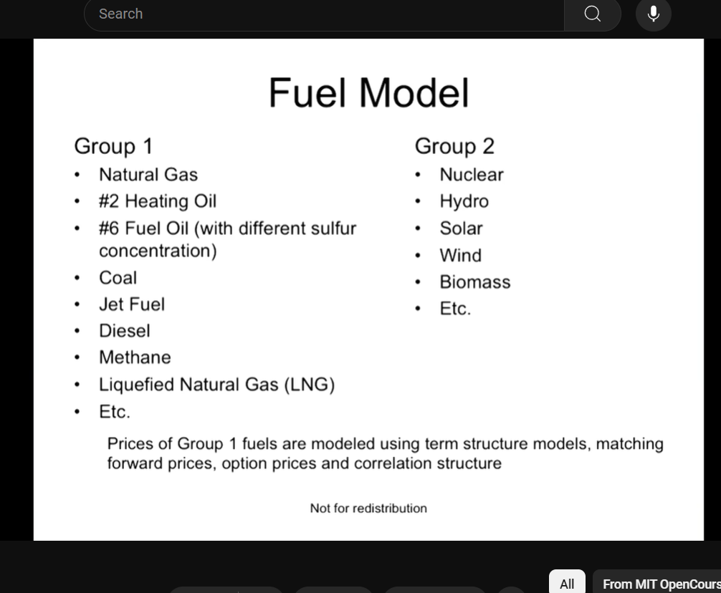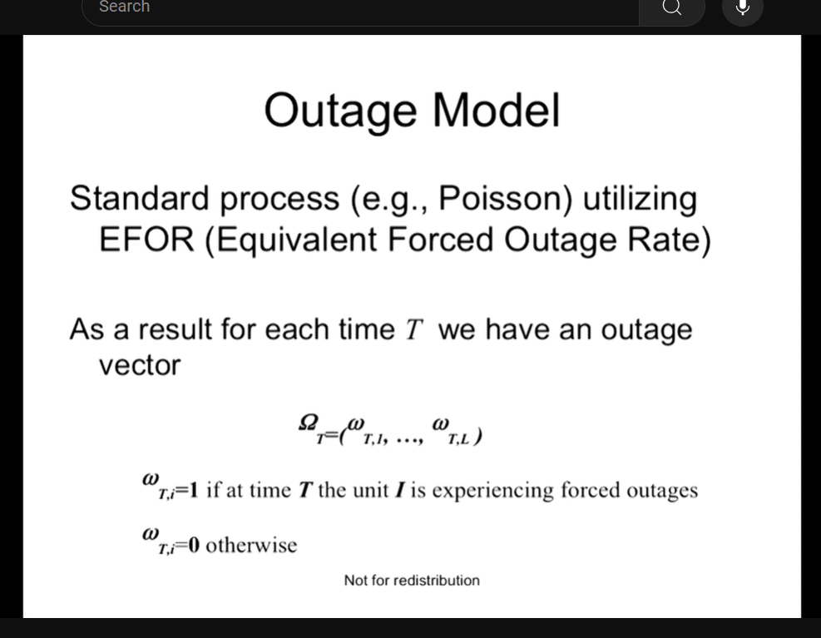

The parameters for the Poisson distribution are given by the government or the plants themselves.

The demand is modeled by the temperature so you first model the temperature then you model the demand and the demand uses temperature right.

So what you see from here is first he plots that exponential function and that is supposed to be the bid stack or generation stack curve because now you have essentially mapped the generation a curve to mimic the bid stock curve. So you can use the words interchangeably. And obviously for on the X axis you have demand and on the Y axis you have price and obviously the greater the demand the higher the price of power again because You start to use more uh plans that are less efficient. And the distribution that he painted on the X axis there are two distributions but they're for the same thing it's for demand so basically what he's trying to say is that if demand is low the distribution shows you the changes in demand and the change those changes in demand plotted on the exponential curve on the generation curve you'll see that they correspond to low price movements now that happens for the first distribution that one that's closer to the origin the further the the distribution that's further away meaning that the demand is settling higher right so think of the expected demand that's where he makes that middle line so if the expected demand is greater then having the same distribution of demand which is again given by prices will result in higher price changes you literally can look and plot the distribution to the values of the generation curve I mean only look at the right half and you can see that it plots to much higher prices. And this basically results in big spikes high volatility and this is what commodities are known for and now you know why that happens why there are significant spikes and volatility.

So to be complete temperature is mean reverting that is what he claims so basically in about a week's time you will revert to your expected demand because you will revert to your expected temperature and as a result you will plummet from that very high price level back to historical prices so that is basically the second stage of a spike you have the upward movement and then the the the downward movement that's that's caused otherwise you would just settle at a higher price going forward right it wouldn't be a spike.

So basically look at the distribution of of the generation stack or the bid stack and you want to use that distribution to ohh model energy prices power prices. And from what he has shown is that um the this it can be done. So to objectively measure how good your distribution follows the actual market distribution of energy prices so you're basically comparing 2 distributions 1 stemming from the model that you basically created and the other stemming from the market which is empirical data that you collect and you look at two things the skewness and the kurtosis of those distributions and if they are equal then basically the skewness of the model is equal to the skewness of the empirical data and the cortosis of the of the models distribution is equal to the kurtosis of the market data distribution then you know you have created a model that generates a distribution that follows quite closely the distribution of energy prices or price you think of it like as 1 commodity so power price

Another thing he does is he looks at the correlation between energy end fuel prices that are coming from the market so this is literally market data actual correlation. Then he he spits the correlation between the energy and fuel prices that are given by the models used for deriving the energy and fuel price distributions. And he's basically getting something similar which is good.

The biggest hurdle to do the above is knowing the participants meaning the plants that ran every day for the past ten years or so for which you are collecting data. You basically need to know which plants are running which plants are going to be built which plants are going to be destroyed you need to know the market participants every time.